History Review (Bills, laws, parliament, senate) Names ______________________________

This quiz has two parts.

- Complete part 1. (This may require some research)

- Send me your answers.

- I will then send you part 2

- Send me your second set of answers

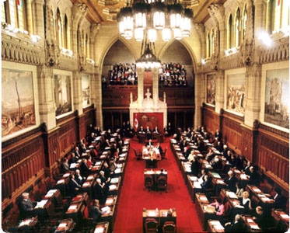
- What is this place?

- How many senators are in the Senate of Canada?

- What is a bill?

- In what decade was the first woman appointed to the Senate?

- What does “Chamber of Sober Second Thought” mean?

