English Assignment – Due Sunday 6PM
Essay #2

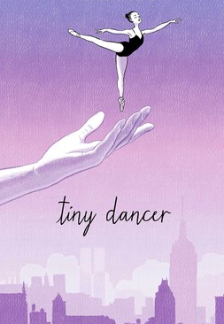
We have worked all week on the Tiny Dancer by Elton John. You have analyzed the people in the video. You have a good understanding of what is happening. Now you are going to write a creative story about one of the characters.

Here are some directions:

- Choose a character
- Tell his / her story . . . use clues from the video
- You don’t need to include anyone else from the video, but you may
- Remember that stories generally have a beginning, middle, and ending
- Use at least 2 lines from the song
- Make it interesting and surprising
- Remember, most of the story comes from your imagination.
- 500 – 600 words min.

