Day of Champions!

Science
First a quick review:

- List ten things you know about water

- What is the formula for density?

- If a metal bar weighs 236 grams and measures 10 cms X 23 cms X 29 cms what is its density?

- Why do heavy logs float?

- If a liquid has a PH of 3 what would you say about it?

New ideas

Why do we explore space?

What is an atom?

What is between atoms?

Science is about measurement. Can we measure everything? Is there anything we cannot measure?

Back to review

List the 9 steps in a science lab experiment

Final

Write a 200-word letter to our government about our environment – give them suggestions about how they can improve our world. Remember, it is a letter so format it like a letter.

Day of Champions!

Art

1- Go out side and find some colourful leaves. Bring them in and put them in-between wax paper
and then in a book under weights. We will be doing art with them next week.

2- Write a poem about the fall on a piece of art paper – remember, this is art class so be
artistic.

Day of Champions!

Math

- Fractions

1/3 – 1/9 = 2/5 * 4/7 = 2/8 – 1/8 =

- Find the mean, median and mode for the following stats about the number of cigarettes people smoke in a day:

5, 6, 8, 9, 4, 2, 1,4, 7, 10, 21, 3, 5

Make a statement about cigarette smokers based on the data

- Interpret the following graphs:

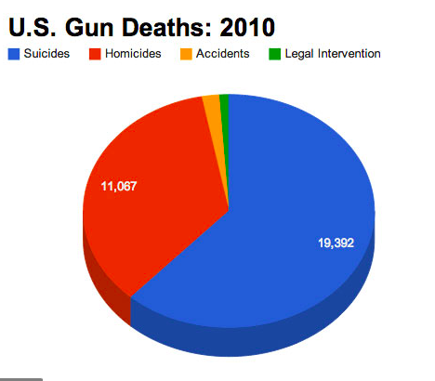

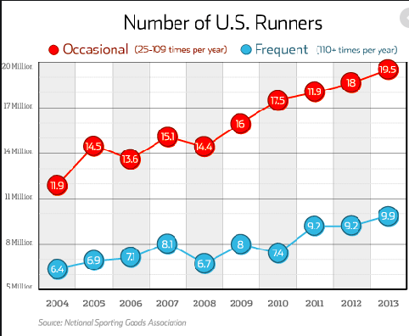

Make a pie chart, graph or bar chart about how you spend day (school, sleep, food, friends. . .)

Day of Champions!

Project

Make up 10 questions to ask someone in the school (write them out)

Ask the questions to the person and write down their answers.

Write a 200 word descriptive essay about the person. Don’t include his name. We will read them and try to figure out who the person is from your details.

